PAPER TITLE IN CAPITAL LETTERS, TIMES NEW ROMAN SIZE 16 POINT BOLD, CENTERED, WRITTEN 3 LINE SPACES (POINT 12) DOWN FROM THE TOP OF THE TYPING AREA

Name Initials followed by Surname in full* (i.e. P.C. Yannopoulos and I.D. Manariotis) in bold lower case letters 13pt, centered and separated from the title by one-line space
Organization and full address, centered, 12pt characters. Specify by “*” the corresponding author.

Leave one-line space and write the e-mail, phone or fax of the corresponding author only, centered, 12pt characters.

Abstract
The abstract of the full paper should be up to 20 lines, while of the extended summary up to 10 lines. The abstract in both cases is written single-spaced with Times New Roman size 12 completely justified.
Keywords
Write up to six keywords separated by semicolons written with Times New Roman size 12.

1. INTRODUCTION

Leave one-line space from the keywords and start writing the main text of the article. Headings should be set aligned left, and consecutively numbered (e.g. 1. INTRODUCTION, 2. MATERIALS AND METHODS, etc., 5. CONCLUSIONS). ACKNOWLEDGEMENTS and REFERENCES follow after CONCLUSIONS and are written without numbering. The main headings should be separated by one-line space from the text above and below, in bold capital letters. The secondary headings should be separated by one-line space from the text above, in bold characters and consecutively numbered (e.g. 1.1 Literature review, 1.2 The present situation, etc.). Only the first word should start with a capital and the rest in lower case letters, in bold characters.
The main text of the manuscript should be written in English, using PC-based MS Word software, single-spaced throughout, justified, in A4 paper size with 2 cm margins from all sides. The maximum length of the full paper is 10 pages, while the length of the extended summary is at least 2 pages and up to 4 pages. Use Times New Roman 12 point characters, throughout the manuscript, unless specified otherwise. Separate paragraphs using a 6pt margin.
Equations should be written in a separate line, left justified and consecutively numbered by Arabic numerals. Place the number of equations in parentheses at the right page margin and refer to them by Equation 1, Equation 2 and so on in the text, as in the following:
(1)
Tables should be included in the main text, preferably after they are cited and as close as possible to their first citation and should be consecutively numbered by Arabic numerals. Write the word "Table" and the corresponding number (in bold characters) and then the table caption above the table columns. Table caption should be separated by the text above by one-line space. Tables should be referred in the text by Table 1, Table 2 and so on. For example, see Table 1.

Table 1. Characteristics of wells, fractures and plumes.
Object | x-coord (m) | y-coord (m) | Radius (m) | Object | x-coord (m) | y-coord (m) | Length (m)
Well 1 | 753.275 | 1373.927 | 0.25 | Fracture 1 Start | 645.561 | 1605.924 | 70
Well 2 | 1451.369 | 1237.570 | 0.25 | Fracture 1 End | 688.038 | 1662.313 | 70
Plume 1 | 510.893 | 1878.212 | 50 | Fracture 2 Start | 1508.571 | 971.469 | 50
Plume 2 | 1673.430 | 683.058 | 60 | Fracture 2 End | 1525.572 | 924.448 | 50

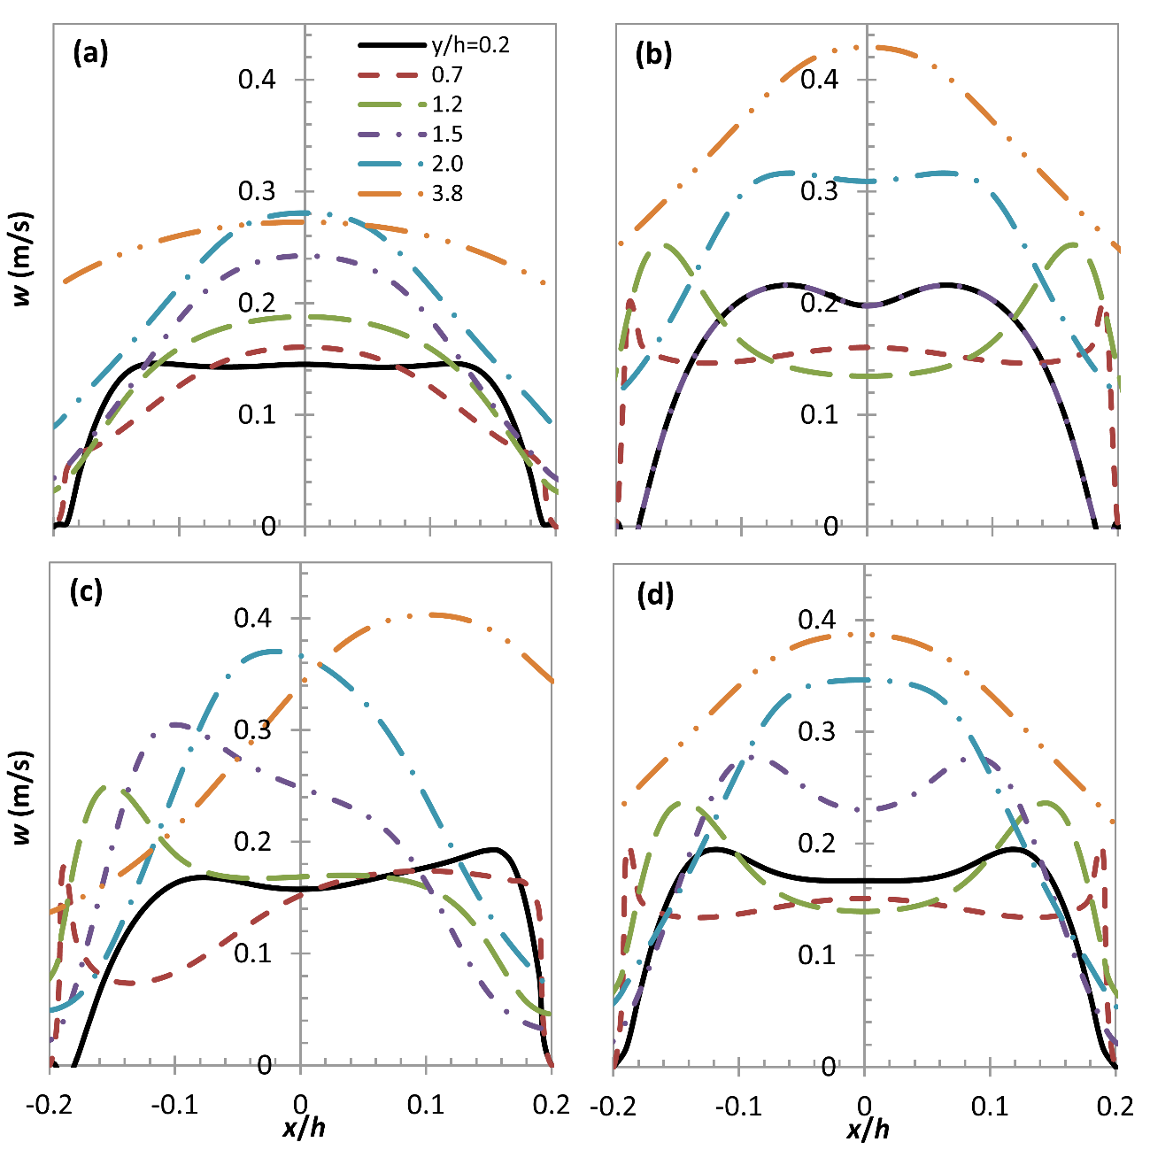
All drawing, graphs and photos should be as clear as possible, and should be included in the text as an integrated file. Figures should not exceed the margins of the typing area and should be consecutively numbered by Arabic numerals. Write the word "Figure" and the corresponding number (in bold characters) and then the figure caption below the figure. Figures should be numbered in the order that they are first cited in the text and they should be placed as close as possible to their first citation and either at the top or at the bottom of the text in the page of first citation or in next page. Figure should be referred in the text by Figure 1, Figure 2 and so on. For example, see Figure 1.
Figure 3. Transverse profiles at several heights of axial velocities for the simulated: (a) Scenario I; (b) Scenario II; (c) Scenario III; and (d) Scenario IV.
Figure 1. Transverse profiles at several heights of axial velocities for the simulated: (a) Scenario I; (b) Scenario II; (c) Scenario III; and (d) Scenario IV.
Please ensure that the following system is used for all scientific and laboratory data: kg for kilogram, L for liters and g for grams. Chemical formulas should also be correct e.g. CO₂ (not CO2). Decimal numbers must have a dot "." as a decimal point and not a comma ",". For example, 2.5 (not 2,5). Groups of three digits in numbers greater than 999 should not be separated by a space or comma, e.g 2500 (not 2 500 or 2,500).
References to works cited in the article should mention the name of the author and the year of publication. References should be listed at the end of the text in the order that they appear in text, headed by the word "References". Use the format recommended below for journal articles, conference proceedings, books, standard test methods, electronic publications.
Example for Journals
1. Chen, C. Y., Yeh, K. L., Aisyah, R., Lee, D. J. and Chang, J.S. (2011). “Cultivation, photobioreactor design and harvesting of microalgae for biodiesel production: A critical review”. Bioresource technology, 102, pp. 71-81.

Example for Conference proceedings
2. Mavrommatis, A. and Christodoulou, G. (2016). Flow field experiments in a channel with artificial vegetation. In: Proc. 13th International Conference on Protection and Restoration of the Environment, Mykonos island, Greece, 2016.

Example for Books
3 Walker, T. D. (1991). Planting Design (Second Edition). PDA Publishers Corporation.

Example for Standard test methods
4. Clesceri, L., Greenberg, A., Eaton, A., Franson, M., Association, A. P. H., Association, A. W. W.and Federation, W. E. (1998). Standard Methods for the Examination of Water and Wastewater. STANDARD METHODS FOR THE EXAMINATION OF WATER AND WASTEWATER. 20. American Public Health Association.

Example for Electronic publications
5. International Renewable Energy Agency (IRENA) (2016). End-of-life management: Solar Photovoltaic Panels. https://www.irena.org/publications/2016/Jun/End-of-life-management-Solar-Photovoltaic-Panels, (accessed 16th April 2019).

Example for Technical reports

6. Eurostat (2019). People who can't afford to keep their home adequately warm. Tech. rep. European Committee.

